PAT-TRAP® SERIAL NUMBER LOCATION

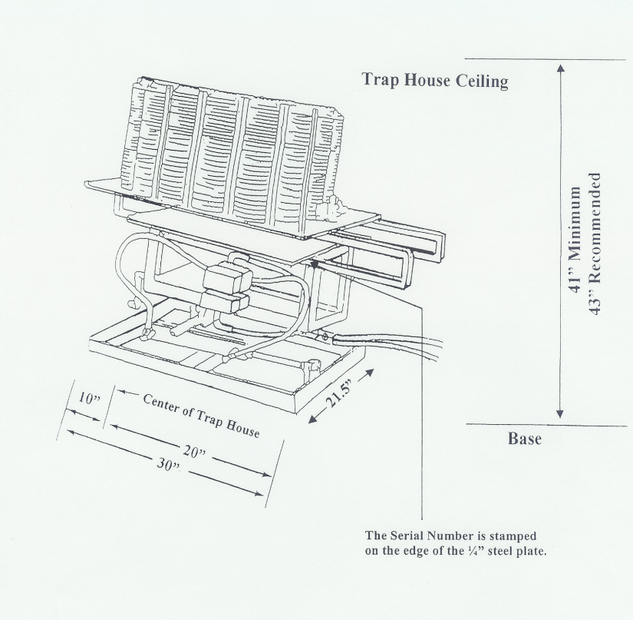
The Serial Number is stamped on the edge of the ¼” steel plate.
Measurements of the Pat-Trap machine

From the bottom of the base to the top of the King Pin 24”

From the bottom of the base to the top of the turret 34 ¾ “

Trap cog top max – 39 ½ ”
Trap cog bottom min – 37”

Wobble base to throw plate (up/down angles) min 17 ¾”

Wobble base to throw plate (up/down angles) max 24 ½ “

Wobble max – 39 ½ “
Wobble Min – 34 ¾ “
Diagram 4
notch
A fully crated Pat-Trap is 500 #.
Machine and pump weighs 350 #.
Turret weigh 50 #.
Pump weight 50 #.
Pat-Trap machine w/o pump and turret weight 250 #.
Pallet Dimensions are 46X38X38
43”

Base Dimensions of PAT-TRAP®

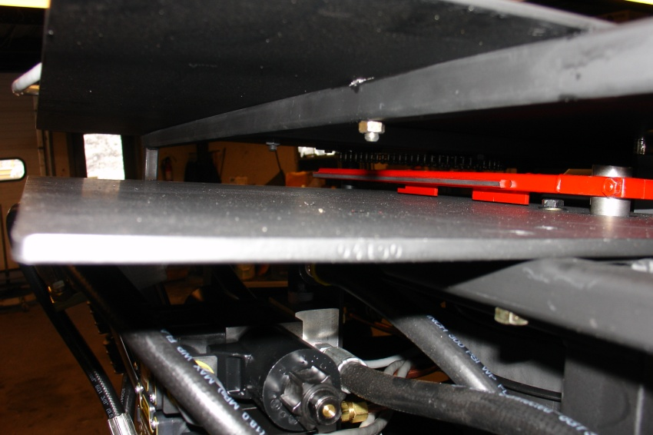
Serial Number is stamped here.
Example: “G4190”
Also located on pump.
Diagram 5

PAT-TRAP® Serial Number Location

Serial Number Location: The Serial Number is stamped on the front left edge (shooting stand 1 Side) of the ¼” thick steel “Throw Plate”.

